  Here’s how it works…  - We will be showing eight films of actual horse races throughout the evening, each with eight numbered horses.  - Place a bet at the tote table on whichever horse you think will win the race.  - You can bet on as many horses as you like, as much as you like. (in min: stake units)  - You will be given a ticket for each bet. Hold on to this, you’ll need it to claim your winnings.  - When all bets have been placed, the race will be shown and the winner displayed.  - If your horse is the winner, collect your winnings from the tote table.  With thanks to our horse owners and race sponsors  www.thoroughbredracenights.com |  | Welcome to the  THOROUGHBRED  RACE EVENING  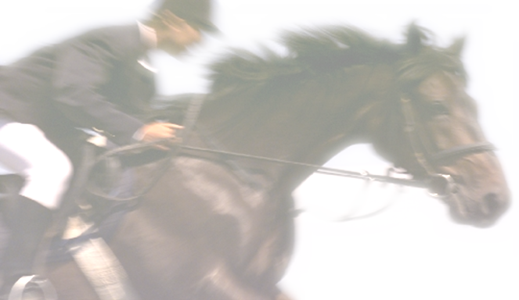  Monday 1st January 2014  www.thoroughbredracenights.com

Race 1 SPONSORED BY  - JORDAN Type the names  - JOHNNIE Of your horse  - GOLDEN REWARD Owners here  - SAILING THROUGH Sarah Jones  - LOST John Smith    - MAGIC Sarah Jones  - LAST ONE IN John Smith  - SEE YOU SOON Sarah Jones  Race 2 SPONSORED BY  - CHOCOLATE Sarah Jones  - PETER John Smith  - RESTLESS Sarah Jones  - NEW YORKER John Smith  - HOT Sarah Jones  - LOST FOR WORDS John Smith  - PAYBACK Sarah Jones  - RANDOM John Smith  Race 3 SPONSORED BY  - EARLY RISER Sarah Jones  - GEE GEE John Smith  - IN AT THE DEEP END Sarah Jones  - DROPPED THEM AGAIN John Smith  - SHOULDN'T DO THAT Sarah Jones  - OVER THE HILL John Smith  - MAKE IT LAST Sarah Jones  - TAX ACCOUNT John Smith  Race 4 SPONSORED BY  - SQUARE BALL Sarah Jones  - BORING OLD FAT John Smith  - FINISHED TOMORROW Sarah Jones  - NO CHANGE John Smith  - UP THE MIDDLE Sarah Jones  - PULLED UP SHORT John Smith  - LONG WAY DOWN Sarah Jones  - HOT AND BOTHERED John Smith |  | Race 5 SPONSORED BY  - LUCKY Sarah Jones  - GRAFFITI John Smith  - HOT LEGS Sarah Jones  - FIRST OUT OF THE STALLS John Smith  - HOOTER Sarah Jones  - PICKLE John Smith  - GLADIATOR Sarah Jones  - WILD RIDE John Smith  Race 6 SPONSORED BY  - GONE IN A FLASH Sarah Jones  - DO IT AGAIN John Smith  - INDIANA Sarah Jones  - FUZZY PICTURE John Smith  - NAUGHTY BUT NICE Sarah Jones  - CAUGHT IN THE ACT John Smith  - ENTERTAINER Sarah Jones  - WITCH John Smith  Race 7 SPONSORED BY  - NUNS CHORUS Sarah Jones  - WITHDRAWAL John Smith  - FREE AT LAST Sarah Jones  - LOST FOR WORDS John Smith  - PLAIN JANE Sarah Jones  - NEW BORN John Smith  - WHO CAME FIRST Sarah Jones  - BLAIR John Smith  Race 8 SPONSORED BY  1. RING May be sold on night  2. BUFFALO BILL as Auction Race  3. SEX BOMB  4. RUNNING SCARED  5. PUSSY GALORE  6. NICE TRY  7. BEATLE  8. TOY STORY

